Net 1060 Introduction to Networks Lab: # 12.9.2

Name:

Follow the instructions down below for the lab itself. For this lab, all answers need to be in blue font. For the questions right below, answer in complete sentences. Ensure you paste the screen shot of your score page at the bottom of the document. Even if this does not let you see your grade, still take a screen shot of the score page showing congratulations “your name” you have completed the exercise is pasted at the bottom of this document. You will then need to upload both this word document and your packet tracer file to the assignments link within Netacad. Let the instructor know if you have any questions.

Lab Analysis Report

1. Using complete sentences summarize work you completed during the lab.
First, I connected all the devices together with the proper cabling. Then, I configured the router and switch and assigned them ipv6 addresses and link-local addresses. Then, I configured the ipv6 addresses for the PCs. Finally, I tested the connectivity between them.

2. Using complete sentences describe what you learned from the lab. Hint; look at the lab objectives listed at the top of the lab section.
In this lab I learned how to assign ipv6 addresses. I also learned more about the link-local address and how it is used within a network. I also learned more about how these addresses work together and how they translate into the real world.

Problems Encountered

1. Using complete sentences describe any problem(s) experienced during lab.
I was not able to figure out what the last objective was looking for.

2. Using complete sentences describe how you solved your problem(s).
I did not solve my problem.

3. Using complete sentences explain if you needed any assistance with the lab; then list what you learned from that assistance.
I did not seek assistance.

Packet Tracer - Configure IPv6 Addresses on Network Devices - Physical Mode

Topology
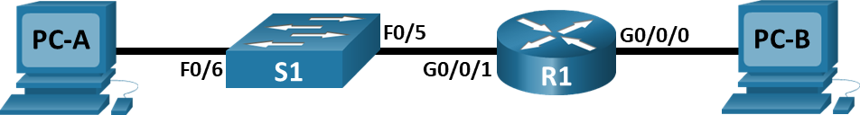

Addressing Table
Device | Interface | IPv6 Address | Prefix Length | Default Gateway
R1 | G0/0/0 | 2001:db8:acad:a::1 | 64 | N/A
R1 | G0/0/1 | 2001:db8:acad:1::1 | 64 | N/A
S1 | VLAN 1 | 2001:db8:acad:1::b | 64 | N/A (fe80::1)
PC-A | NIC | 2001:db8:acad:1::3 | 64 | fe80::1
PC-B | NIC | 2001:db8:acad:a::3 | 64 | fe80::1
Blank Line - no additional information

Objectives
Part 1: Set Up Topology and Configure Basic Router and Switch Settings
Part 2: Configure IPv6 Addresses Manually
Part 3: Verify End-to-End Connectivity

Background / Scenario
In this Packet Tracer Physical Mode (PTPM) activity, you will configure hosts and device interfaces with IPv6 addresses. You will issue show commands to view IPv6 unicast addresses. You will use ping and traceroute commands to verify end-to-end connectivity.

Instructions

Cable the Network and Configure Basic Router and Switch Settings
In this part, you will cable the network, power the devices, and then configure the router and switch with basic device settings.

Cable the network and power the devices.
Cable the network according to the topology. Power the devices as needed.

Configure the router.
Assign the hostname and configure the basic device settings.

Configure the switch.
Assign the hostname and configure the basic device settings.

Configure IPv6 Addresses Manually
In this part, you will manually configure IPv6 addressing on all the devices in the network.

Assign the IPv6 addresses to Ethernet interfaces on R1.
      - Assign the IPv6 global unicast addresses, listed in the Addressing Table, to both Ethernet interfaces on R1.
Open configuration window
      - Verify that the correct IPv6 unicast address is assigned to each interface.
Note: The link-local address (fe80::) displayed is based on EUI-64 addressing, which automatically uses the interface Media Access Control (MAC) address to create a 128-bit IPv6 link-local address.
      - To get the link-local address to match the global unicast address on the interface, manually enter the link-local addresses on each of the Ethernet interfaces on R1.
Note: Each router interface belongs to a separate network. Packets with a link-local address never leave the local network; therefore, you can use the same link-local address on both interfaces.
      - Use a command of your choice to verify that the link-local address has been changed to fe80::1.
Close configuration window

Question:
Which two multicast groups have been assigned to interface G0/0/0?
The two multicast groups are FF02::1 and FF02::1:FF00:1. answers here.

Enable IPv6 routing on R1.
      - From a PC-B command prompt, enter the ipconfig command to examine the IPv6 address information assigned to the PC interface.

Question:
Has an IPv6 unicast address been assigned to the network interface card (NIC) on PC-B?
No, there is no IPv6 address assigned. your answers here.
      - Use the IPv6 unicast-routing command to enable IPv6 routing on R1.
Open configuration window
      - Use a command to verify the new multicast group is assigned to interface G0/0/0. Notice that the all-router multicast group (ff02::2) now appears for interface G0/0/0.
Note: This will allow the PCs to obtain the IP address and default gateway information automatically using Stateless Address Autoconfiguration (SLAAC).
      - Now that R1 is part of the all-router multicast group FF02::2, from PC-B re-issue the ipconfig command and examine the IPv6 address information.

Question:
Why did PC-B receive the Global Routing Prefix and Subnet ID that you configured on R1?
PC-B received the prefix and ID because they are locally linked. your answers here.

Assign IPv6 addresses to the management interface (SVI) on S1.
      - Assign the IPv6 address for S1. Also assign a link-local address for this interface.
Note: The switch will automatically receive its default gateway address from the RA message sent by the router. It will use the source IPv6 address of the RA message, which is the router's link-local address. However, your version of Packet Tracer may not yet support this on the switch.
      - Use a command of your choice to verify that the IPv6 addresses are properly assigned to the management interface.
Close configuration window

Assign static IPv6 addresses to the PCs.
      - Open the IP Configuration window on each PC and assign IPv6 addressing.
      - Verify both PCs have the correct IPv6 address information. Each PC should have two Global IPv6 addresses: one static and one SLAAC.

Verify End-to-End Connectivity
- From PC-A, ping fe80::1. This is the link-local address assigned to G0/0/1 on R1.
- From PC-A, use the tracert command to verify that you have end-to-end connectivity to PC-B.
- From PC-B, ping PC-A.
- From PC-B, ping the link-local address for G0/0/0 on R1.
Note: If end-to-end connectivity is not established, troubleshoot your IPv6 address assignments to verify that you entered the addresses correctly on all devices.

Reflection Questions
  - Why can the same link-local address, fe80::1, be assigned to both Ethernet interfaces on R1?
Because they are in the same local network. your answers here.
  - What is the Subnet ID of the IPv6 unicast address 2001:db8:acad::aaaa:1234/64, if the global routing prefix is a /48?
The subnet ID would be 0.
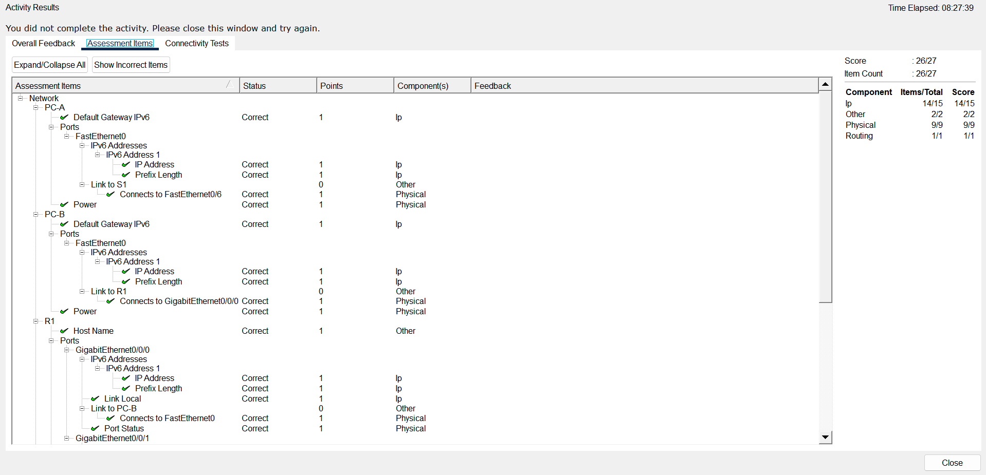
End of document

